VISVESVARAYA TECHNOLOGICAL UNIVERSITY
“JnanaSangama”, Belgaum -590014, Karnataka.


LAB REPORT

On

ANALYSIS AND DESIGN OF ALGORITHMS (23CS4PCADA)

Submitted by

Ananya Galagali (1BM24CS040)

in partial fulfillment for the award of the degree of
BACHELOR OF ENGINEERING
in
COMPUTER SCIENCE AND ENGINEERING


B.M.S. COLLEGE OF ENGINEERING
(Autonomous Institution under VTU)
BENGALURU-560019
February to June 2026
CERTIFICATE

B. M. S. College of Engineering,
Bull Temple Road, Bangalore 560019
(Affiliated To Visvesvaraya Technological University, Belgaum) Department of Computer Science and Engineering



This is to certify that the Lab work entitled “ANALYSIS AND DESIGN OF ALGORITHMS” carried out by Ananya Galagali (1BM24CS040), who is bonafide student of B. M. S. College of Engineering. It is in partial fulfillment for the award of Bachelor of Engineering in Computer Science and Engineering of the Visvesvaraya Technological University, Belgaum during the year 2025-26. The Lab report has been approved as it satisfies the academic requirements in respect of Analysis and Design of Algorithms Lab - (23CS4PCADA) work prescribed for the said degree.

Kanchana M Dixit Dr. Kavitha Sooda
Assistant Professor Professor and Head
Department of CSE Department of CSE
BMSCE, Bengaluru BMSCE, Bengaluru

Index Sheet
Sl.  No. | Experiment Title | Page No.
1 | Write program to obtain the Topological ordering of vertices in a given digraph. | 4
2 | Implement Johnson Trotter algorithm to generate permutations. | 9
3 | Sort a given set of N integer elements using Merge Sort technique and compute its time taken. Run the program for different values of N and record the time taken to sort. | 12
4 | Sort a given set of N integer elements using Quick Sort technique and compute its time taken. | 15
5 | Sort a given set of N integer elements using Heap Sort technique and compute its time taken. | 18
6 | Implement 0/1 Knapsack problem using dynamic programming. (5 Marks) | 21
7 | Implement All Pair Shortest paths problem using Floyd’s algorithm. | 25
8 | - Find Minimum Cost Spanning Tree of a given undirected graph using Prim’s algorithm.  - Find Minimum Cost Spanning Tree of a given undirected graph using Kruskal’s algorithm. | 29  32
9 | Implement Fractional Knapsack using Greedy technique. | 35
10 | From a given vertex in a weighted connected graph, find shortest paths to other vertices using Dijkstra’s algorithm. | 38
11 | Implement “N-Queens Problem” using Backtracking. | 41

Course outcomes:
CO1 | Analyze time complexity of algorithms using asymptotic notations.
CO2 | Apply various algorithm design techniques for the given problem.
CO3 | Evaluate the appropriate algorithm/design technique for solving a given problem.
CO4 | Conduct practical experiments by applying appropriate algorithm design technique to solve problems.
Lab program 1: Topological Sorting

#include <stdio.h>
#define MAX 10
int main() {
int adj[MAX][MAX], indegree[MAX];
int queue[MAX], front = 0, rear = 0;
int n, i, j, count = 0, v;
printf("Enter number of vertices: ");
scanf("%d", &n);
printf("Enter adjacency matrix:\n");
for(i = 0; i < n; i++) {
for(j = 0; j < n; j++) {
scanf("%d", &adj[i][j]);
}
}
for(i = 0; i < n; i++) {
indegree[i] = 0;
}
for(i = 0; i < n; i++) {
for(j = 0; j < n; j++) {
if(adj[i][j] == 1)
indegree[j]++;
}
}
for(i = 0; i < n; i++) {
if(indegree[i] == 0)
queue[rear++] = i;
}
printf("Topological Order: ");
while(front < rear) {
v = queue[front++];
printf("%d ", v);
count++;
for(j = 0; j < n; j++) {
if(adj[v][j] == 1) {
indegree[j]--;
if(indegree[j] == 0)
queue[rear++] = j;
}
}
}
if(count != n)
printf("\nGraph contains a cycle");
return 0;
}
OUTPUT:
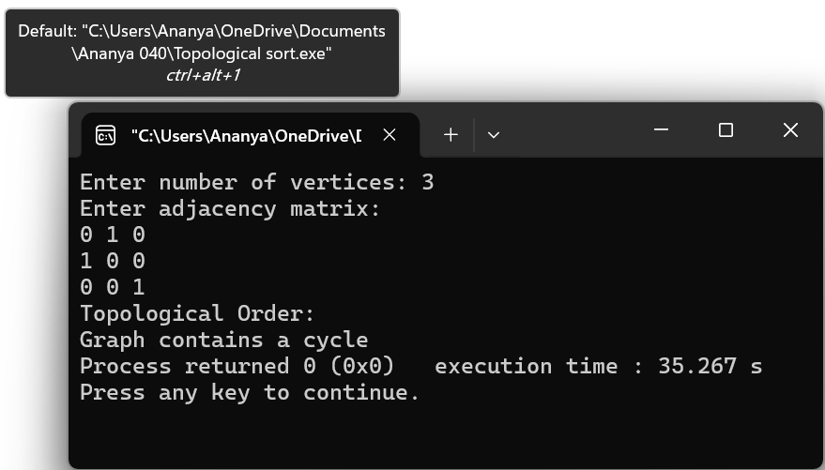
Leetcode Problem (207.Course Schedule):
bool canFinish(int numCourses, int** prerequisites, int prerequisitesSize, int* prerequisitesColSize) {
int* indegree = (int*)calloc(numCourses, sizeof(int));
int** graph = (int**)malloc(numCourses * sizeof(int*));
int* graphColSize = (int*)calloc(numCourses, sizeof(int));
for (int i = 0; i < numCourses; i++) {
graph[i] = (int*)malloc(numCourses * sizeof(int)); // worst case
}
for (int i = 0; i < prerequisitesSize; i++) {
int course = prerequisites[i][0];
int prereq = prerequisites[i][1];
graph[prereq][graphColSize[prereq]++] = course;
indegree[course]++;
}
int* queue = (int*)malloc(numCourses * sizeof(int));
int front = 0, rear = 0;
for (int i = 0; i < numCourses; i++) {
if (indegree[i] == 0) {
queue[rear++] = i;
}
}
int count = 0;
while (front < rear) {
int current = queue[front++];
count++;
for (int i = 0; i < graphColSize[current]; i++) {
int neighbor = graph[current][i];
indegree[neighbor]--;
if (indegree[neighbor] == 0) {
queue[rear++] = neighbor;
}
}
}
for (int i = 0; i < numCourses; i++) {
free(graph[i]);
}
free(graph);
free(graphColSize);
free(indegree);
free(queue);
return count == numCourses;
}

OUTPUT:
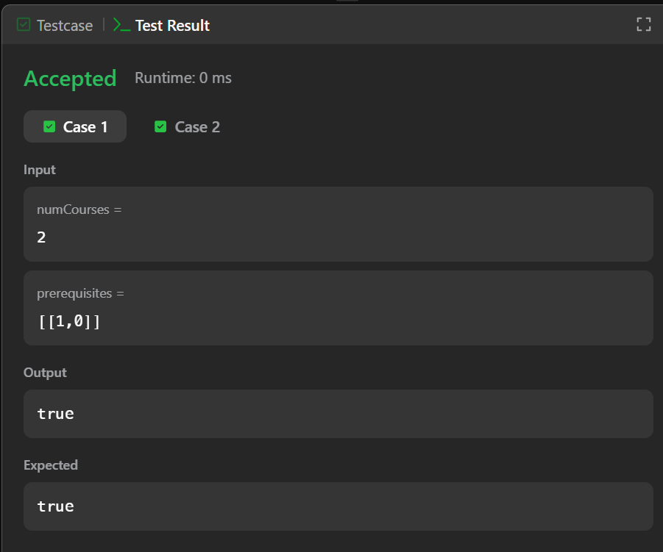
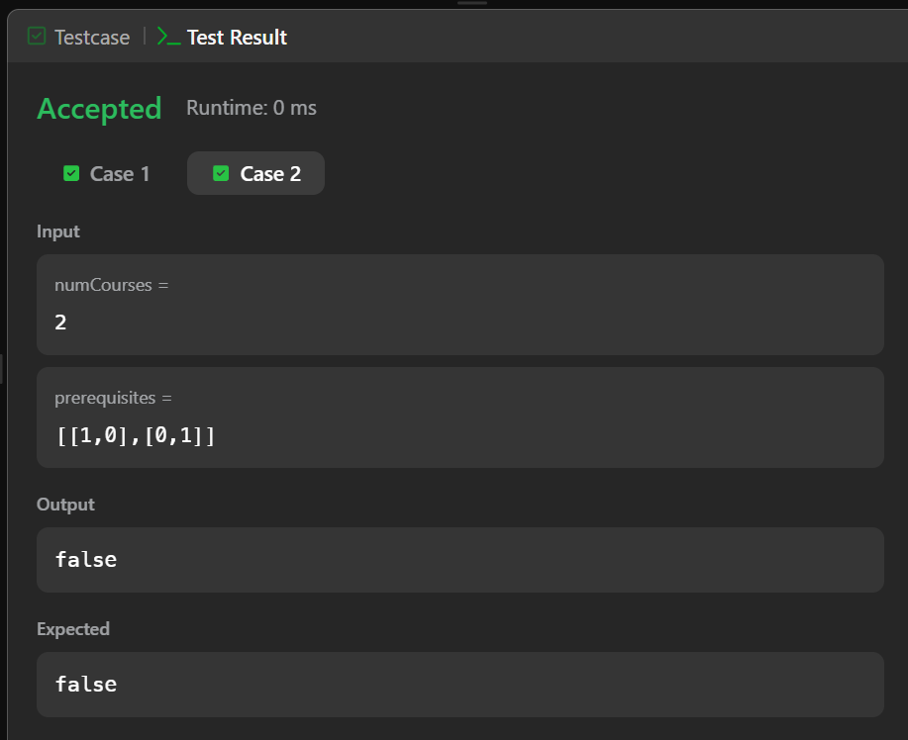

GRAPH:
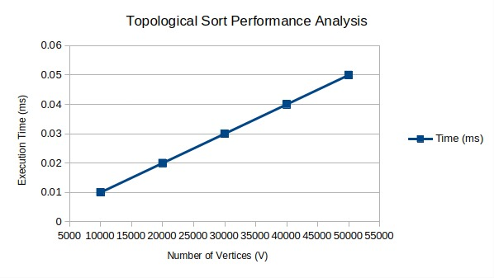

Lab program 2: Johnson Trotter Algorithm
#include <stdio.h>
#define SIZE 5
int a[SIZE], max, pos, n;
char dir[SIZE];
void print()
{
for (int i=0; i<n; i++)
{
printf("%d(%c) ", a[i], dir[i]);
}
printf("\n");
}
int main()
{
printf("Enter n value: ");
scanf("%d", &n);
for (int i=0; i<n; i++)
{
a[i] = i+1;
dir[i] = 'L';
}
print();
while (1)
{
max = -1;
pos = -1;
for (int i=0; i<n; i++)
{
if ((dir[i] == 'L' && i>0 && a[i] > a[i-1]) ||
(dir[i] == 'R' && i<n-1 && a[i] > a[i+1]))
{
if (a[i] > max)
{
max = a[i];
pos = i;
}
}
}
if (max == -1)
break;
if (dir[pos] == 'L')
{
int temp = a[pos];
a[pos] = a[pos-1];
a[pos-1] = temp;
char tempdir = dir[pos];
dir[pos] = dir[pos-1];
dir[pos-1] = tempdir;
}
else
{
int temp = a[pos];
a[pos] = a[pos+1];
a[pos+1] = temp;
char tempdir = dir[pos];
dir[pos] = dir[pos+1];
dir[pos+1] = tempdir;
}
for (int i=0; i<n; i++)
{
if (a[i] > max)
{
char d = dir[i];
if (d == 'L')
dir[i] = 'R';
else
dir[i] = 'L';
}
}
print();
}
return 0;
}
OUTPUT:
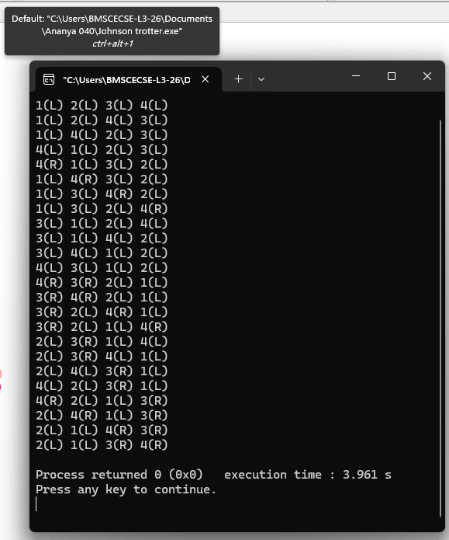

Lab program 3: Merge Sort
#include <stdio.h>
#include<time.h>
int a[20],n;
void simple_sort(int [],int,int,int);
void merge_sort(int[],int,int);
int main()
{
int i;
clock_t start, end;
double time_taken;
printf("Enter the no. of elements:");
scanf("%d", &n);
printf("Enter the array elements:");
for (i = 0; i < n; i++) {
scanf("%d", &a[i]);
}
merge_sort(a, 0, n - 1);
printf("Sorted array:");
for (i = 0; i < n; i++) {
printf("%d ", a[i]);
}
return 0;
}
void merge_sort(int a[],int low, int high){
if(low<high){
int mid=(low+high)/2;
merge_sort(a,low,mid);
merge_sort(a,mid+1,high);
simple_sort(a,low,mid,high);
}
}
void simple_sort(int a[],int low, int mid, int high){
int i=low,j=mid+1,k=low;
int c[n];
while(i<=mid && j<=high){
if(a[i]<a[j]){
c[k++]=a[i];
i++;
}else{
c[k++]=a[j];
j++;
}
}
while(i<=mid){
c[k++]=a[i];
i++;
}
while(j<=high){
c[k++]=a[j];
j++;
}
for(i=low;i<=high;i++){
a[i]=c[i];
}
}
OUTPUT:
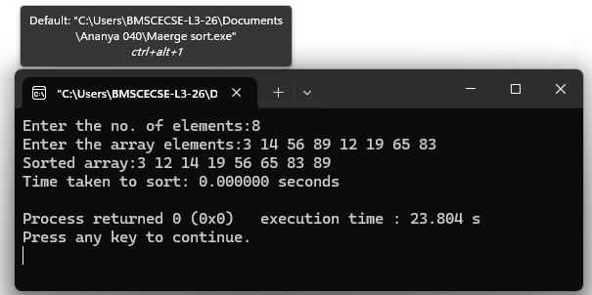

GRAPH:
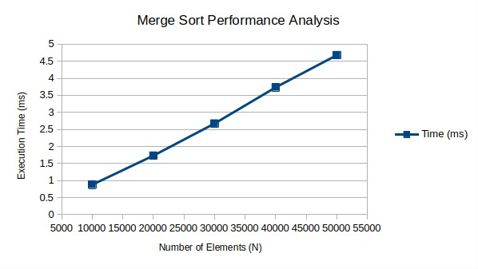

Lab program 4: Quick Sort
#include <stdio.h>
#include<time.h>
int a[20],n;
int partition(int [],int, int);
void quick_sort(int [],int,int);
void swap(int*,int*);
int main()
{
int i;
clock_t start, end;
double time_taken;
printf("Enter the no. of elements:");
scanf("%d", &n);
printf("Enter the array elements:");
for (i = 0; i < n; i++) {
scanf("%d", &a[i]);
}
start = clock();
quick_sort(a, 0, n - 1);
end = clock();
time_taken = (double)(end - start) / CLOCKS_PER_SEC;
printf("Sorted array:");
for (i = 0; i < n; i++) {
printf("%d ", a[i]);
}
printf("\n");
printf("Time taken to sort: %f seconds\n", time_taken);
return 0;
}

void swap(int *a,int *b){
int temp=*a;
*a=*b;
*b=temp;
}
void quick_sort(int a[],int low,int high){
if(low<high){
int mid=partition(a,low,high);
quick_sort(a,low,mid-1);
quick_sort(a,mid+1,high);
}
}
int partition(int a[],int low,int high){
int pivot=a[low];
int i=low;
int j=high+1;
while(i<=j){
do{
i=i+1;
}while(a[i]<pivot && i<=high);
do{
j=j-1;
}while(a[j]>pivot && j>=low);
if(i<j){
swap(&a[i],&a[j]);
}
}
swap(&a[j],&a[low]);
return j;
}
OUTPUT:
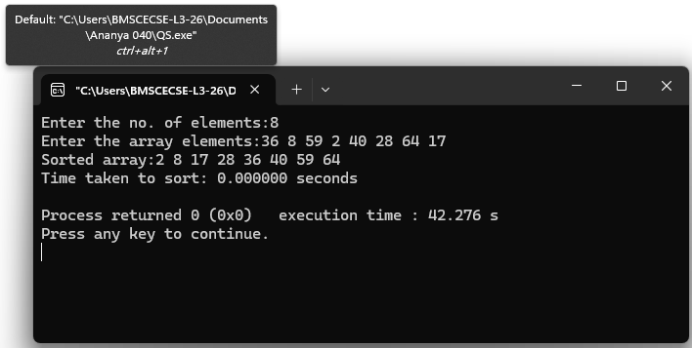
GRAPH:
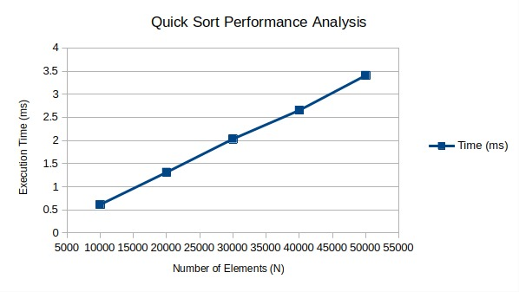

Lab program 5: Heap Sort
#include <stdio.h>
#include <time.h>
void heapify(int a[], int n, int i)
{
int largest = i;
int left = 2 * i + 1;
int right = 2 * i + 2;
int temp;
if (left < n && a[left] > a[largest])
largest = left;
if (right < n && a[right] > a[largest])
largest = right;
if (largest != i)
{
temp = a[i];
a[i] = a[largest];
a[largest] = temp;
heapify(a, n, largest);
}
}
void heapSort(int a[], int n)
{
int i, temp;
for (i = n / 2 - 1; i >= 0; i--)
{
heapify(a, n, i);
}
for (i = n - 1; i > 0; i--)
{
temp = a[0];
a[0] = a[i];
a[i] = temp;
heapify(a, i, 0);
}
}

int main()
{
int a[1000], n, i;
clock_t start, end;
double time_taken;
printf("Enter number of elements: ");
scanf("%d", &n);
printf("Enter elements:\n");
for (i = 0; i < n; i++)
{
scanf("%d", &a[i]);
}
start = clock();
heapSort(a, n);
end = clock();
printf("\nSorted array:\n");
for (i = 0; i < n; i++)
{
printf("%d ", a[i]);
}
time_taken = ((double)(end - start)) / CLOCKS_PER_SEC;
printf("\n\nTime taken = %f seconds\n", time_taken);
return 0;
}

OUTPUT:
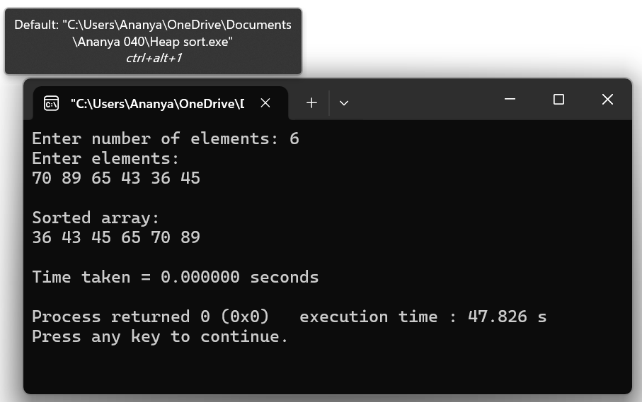

GRAPH:

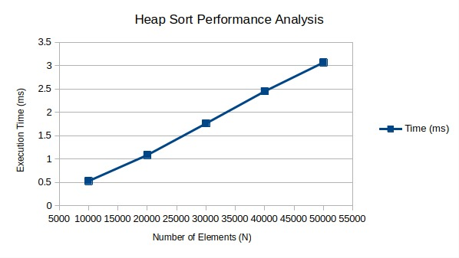
Lab program 6: 0/1 Knapsack Problem Using Dynamic Programming
#include <stdio.h>
int max(int a, int b) {
return (a > b) ? a : b;
}
int knapsack(int n, int M, int W[], int P[]) {
int i, j;
int table[n + 1][M + 1];
for (i = 0; i <= n; i++)
table[i][0] = 0;
for (j = 0; j <= M; j++)
table[0][j] = 0;
for (i = 1; i <= n; i++) {
for (j = 1; j <= M; j++) {
if (j < W[i - 1]) {
table[i][j] = table[i - 1][j];
} else {
table[i][j] = max(
table[i - 1][j],
P[i - 1] + table[i - 1][j - W[i - 1]]
);
}
}
}
return table[n][M];
}
int main() {
int n, M;
printf("Enter number of items: ");
scanf("%d", &n);
int W[n], P[n];
printf("Enter weights of items:\n");
for (int i = 0; i < n; i++) {
scanf("%d", &W[i]);
}
printf("Enter profits of items:\n");
for (int i = 0; i < n; i++) {
scanf("%d", &P[i]);
}
printf("Enter capacity of knapsack: ");
scanf("%d", &M);
int result = knapsack(n, M, W, P);
printf("Maximum Profit = %d\n", result);
return 0;
}
OUTPUT:
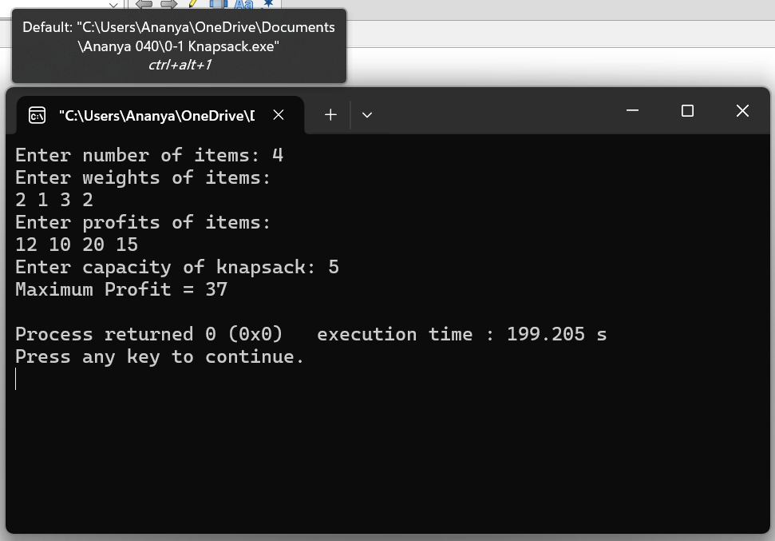

Leetcode Problem (801.Minimum Swaps):
#include <stdio.h>
#include <limits.h>
int minSwap(int* nums1, int nums1Size, int* nums2, int nums2Size) {
int keep = 0; // No swap at current position
int swap = 1; // Swap at current position
for (int i = 1; i < nums1Size; i++) {
int newKeep = INT_MAX;
int newSwap = INT_MAX;
if (nums1[i] > nums1[i - 1] && nums2[i] > nums2[i - 1]) {
newKeep = keep;
newSwap = swap + 1;
}
if (nums1[i] > nums2[i - 1] && nums2[i] > nums1[i - 1]) {
if (swap < newKeep)
newKeep = swap;
if (keep + 1 < newSwap)
newSwap = keep + 1;
}
keep = newKeep;
swap = newSwap;
}
return (keep < swap) ? keep : swap;
}

OUTPUT:
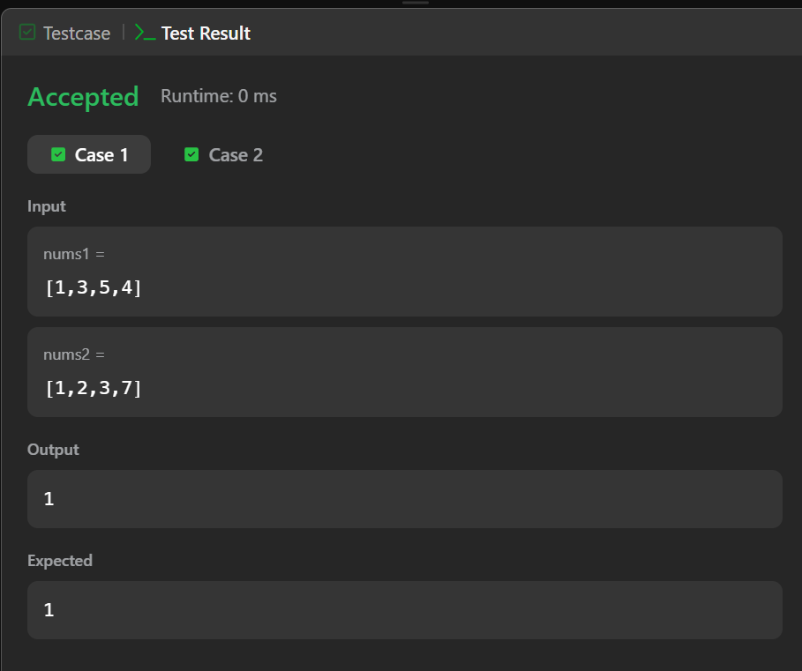

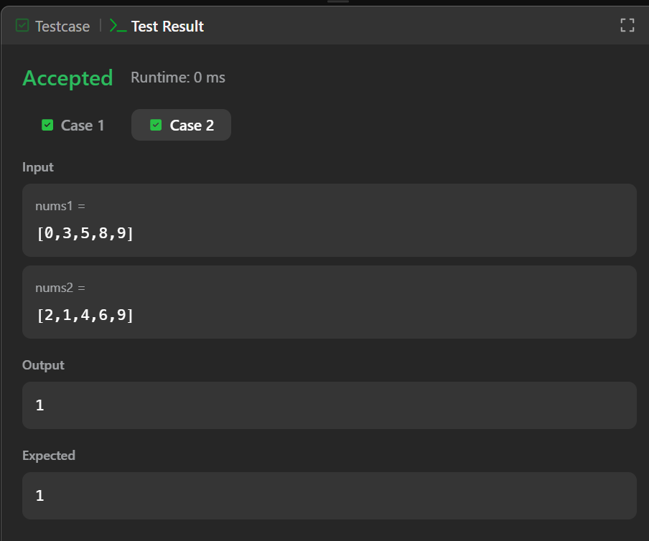

Lab program 7: Floyd’s Algorithm
#include <stdio.h>
int a[10][10],D[10][10],n;
void floyd(int [][10],int);
int min(int,int);
int main()
{
printf("Enter the no. of vertices:");
scanf("%d",&n);
printf("Enter the cost adjacency matrix:\n");
int i,j;
for(i=0;i<n;i++){
for(j=0;j<n;j++){
scanf("%d",&a[i][j]);
}
}
floyd(a,n);
printf("Distance Matrix:\n");
for(i=0;i<n;i++){
for(j=0;j<n;j++){
printf("%d ",D[i][j]);
}
printf("\n");
}
return 0;
}
void floyd(int a[][10],int n){
int i,j,k;
for(i=0;i<n;i++){
for(j=0;j<n;j++){
D[i][j]=a[i][j];
}
}
for(k=0;k<n;k++){
for(i=0;i<n;i++){
for(j=0;j<n;j++){
D[i][j]=min(D[i][j],(D[i][k]+D[k][j]));
}
}
}
}
int min(int a,int b){
if(a<b){
return a;
}else{
return b;
}
}
OUTPUT:
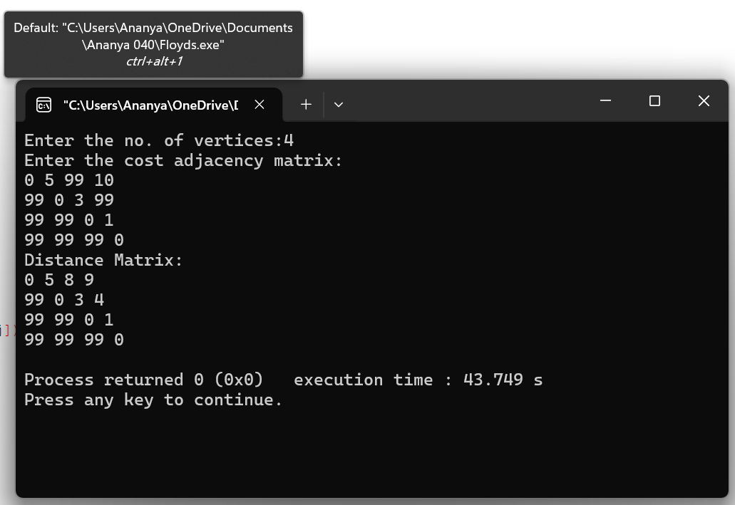
Leetcode Problem (287.Duplicate Number):
int findDuplicate(int* nums, int numsSize)
{
int slow = nums[0];
int fast = nums[0];
while (1)
{
slow = nums[slow];
fast = nums[nums[fast]];
if (slow == fast)
break;
}
slow = nums[0];
while (slow != fast)
{
slow = nums[slow];
fast = nums[fast];
}
return slow;
}

OUTPUT:
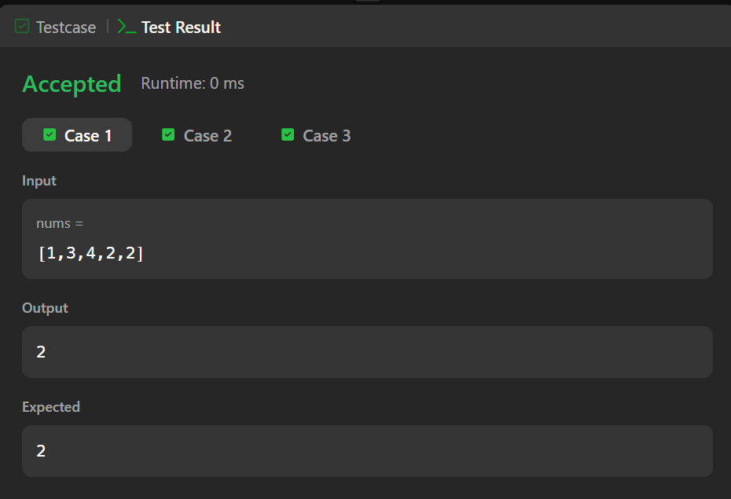
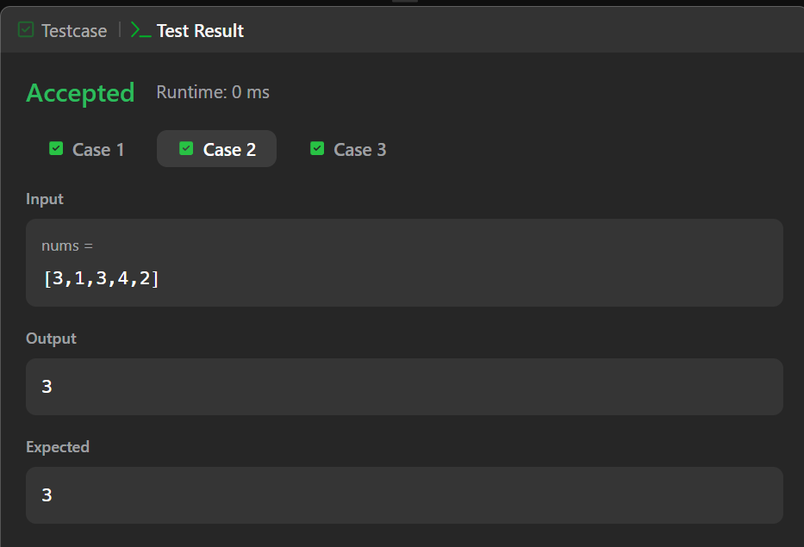

Lab program 8:(a) Prim’s Algorithm
#include <stdio.h>
#define INF 9999
#define MAX 10
void prims(int n, int cost[MAX][MAX]) {
int near[MAX], t[MAX][2];
int i, j, k, l, min, mincost = 0;
min = INF;
for (i = 1; i <= n; i++) {
for (j = i + 1; j <= n; j++) {
if (cost[i][j] < min) {
min = cost[i][j];
k = i;
l = j;
}
}
}
t[1][1] = k;
t[1][2] = l;
mincost = cost[k][l];
for (i = 1; i <= n; i++) {
if (cost[i][k] < cost[i][l])
near[i] = k;
else
near[i] = l;
}
near[k] = 0;
near[l] = 0;
for (i = 2; i <= n - 1; i++) {
min = INF;
for (j = 1; j <= n; j++) {
if (near[j] != 0 && cost[j][near[j]] < min) {
min = cost[j][near[j]];
k = j;
}
}
t[i][1] = k;
t[i][2] = near[k];
mincost += cost[k][near[k]];
near[k] = 0;
for (j = 1; j <= n; j++) {
if (near[j] != 0 && cost[j][near[j]] > cost[j][k]) {
near[j] = k;
}
}
}
printf("\nEdges in MST:\n");
for (i = 1; i <= n - 1; i++) {
printf("%d - %d\n", t[i][1], t[i][2]);
}
printf("Minimum cost = %d\n", mincost);
}
int main() {
int n, cost[MAX][MAX];
int i, j;
printf("Enter number of vertices: ");
scanf("%d", &n);
printf("Enter cost matrix:\n");
for (i = 1; i <= n; i++) {
for (j = 1; j <= n; j++) {
scanf("%d", &cost[i][j]);
if (cost[i][j] == 0)
cost[i][j] = INF;
}
}
prims(n, cost);
return 0;
}
OUTPUT:
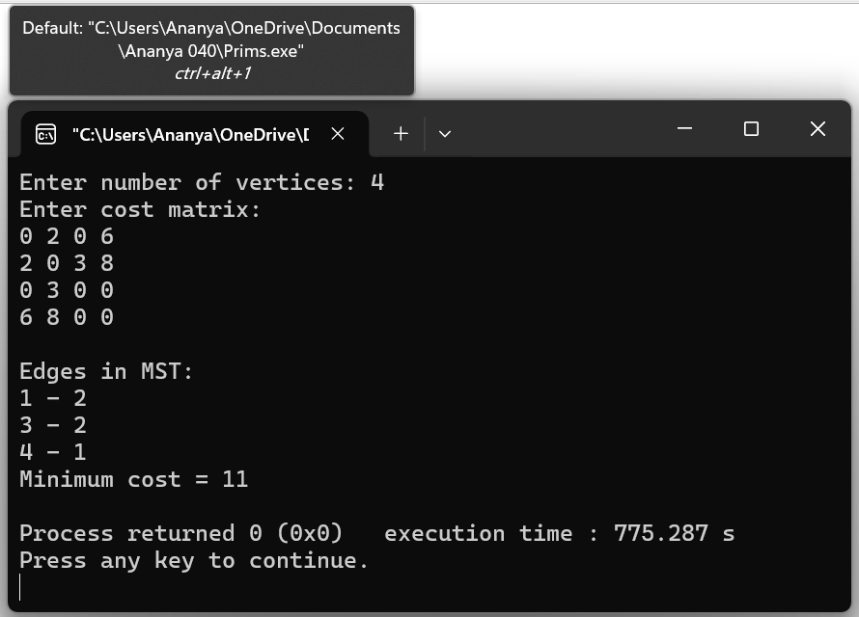
Lab program 8:(b) Kruskal’s Algorithm
#include <stdio.h>
#define MAX 10
#define INF 9999
int parent[MAX];
int find(int i) {
while (parent[i])
i = parent[i];
return i;
}
void union_set(int i, int j) {
parent[j] = i;
}
int main() {
int n, cost[MAX][MAX];
int t[MAX][2];
int i, j, u, v, k;
int min, mincost = 0;
int edge_count = 0;
printf("Enter number of vertices: ");
scanf("%d", &n);
printf("Enter cost matrix:\n");
for (i = 1; i <= n; i++) {
for (j = 1; j <= n; j++) {
scanf("%d", &cost[i][j]);
if (cost[i][j] == 0)
cost[i][j] = INF;
}
}
for (i = 1; i <= n; i++)
parent[i] = 0;
while (edge_count < n - 1) {
min = INF;
for (i = 1; i <= n; i++) {
for (j = 1; j <= n; j++) {
if (cost[i][j] < min) {
min = cost[i][j];
u = i;
v = j;
}
}
}
i = find(u);
j = find(v);
if (i != j) {
edge_count++;
t[edge_count][1] = u;
t[edge_count][2] = v;
mincost += min;
union_set(i, j);
}
cost[u][v] = cost[v][u] = INF;
}
printf("\nEdges in MST:\n");
for (i = 1; i <= edge_count; i++) {
printf("%d - %d\n", t[i][1], t[i][2]);
}
printf("Minimum cost = %d\n", mincost);
return 0;
}
OUTPUT:
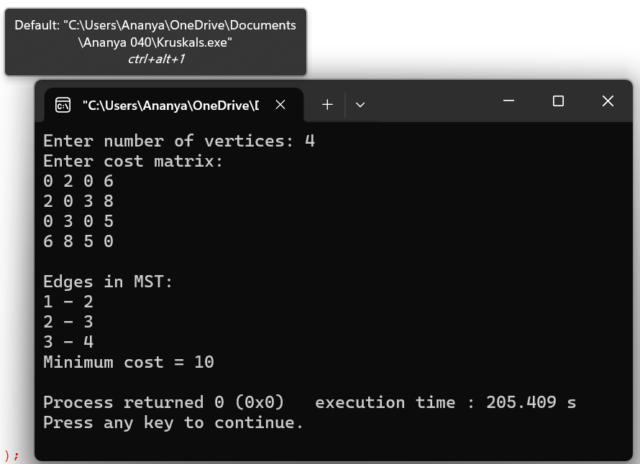

Lab program 9: Fractional Knapsack Using Greedy Technique
#include<stdio.h>
int main()
{
float p[100],w[100],x[100],m,total;
int n,k;
printf("enter the number of items");
scanf("%d",&n);
printf("enter the capacity of knapsack:");
scanf("%f",&m);
for(int i=0;i<n;i++)
{
printf("enter profit value %d: ",i+1);
scanf("%f",&p[i]);
x[i]=0;
printf("enter weight value %d: ",i+1);
scanf("%f",&w[i]);
}
int temp;
for(int i=0;i<n-1;i++)
{
for(int j=i+1;j<n;j++)
{
if(p[i]/w[i]<p[j]/w[j])
{
temp=p[i];
p[i]=p[j];
p[j]=temp;
temp=w[i];
w[i]=w[j];
w[j]=temp;
}
}
}
int rem_cap=m;
for(k=0;k<n;k++)
{
if(w[k]>rem_cap)
{
break;
}
rem_cap=rem_cap-w[k];
x[k]=1;
}
if(k<n)
{
x[k]=rem_cap/w[k];
}
for(int i=0;i<n;i++)
{
total=total+x[i]*p[i];
}

printf("total profit=%f",total);
return 0;
}
OUTPUT:
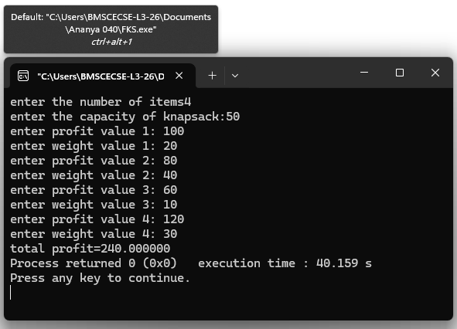

Lab program 10: Dijkstra’s Algorithm
#include <stdio.h>
#define INF 99999
int minDistance(int dist[], int visited[], int n) {
int min = INF, min_index = -1;
for (int v = 0; v < n; v++) {
if (!visited[v] && dist[v] <= min) {
min = dist[v];
min_index = v;
}
}
return min_index;
}
void dijkstra(int n, int graph[n][n], int src) {
int dist[n], visited[n];
for (int i = 0; i < n; i++) {
dist[i] = INF;
visited[i] = 0;
}
dist[src] = 0;
for (int count = 0; count < n - 1; count++) {
int u = minDistance(dist, visited, n);
if (u == -1) break;
visited[u] = 1;

for (int v = 0; v < n; v++) {
if (!visited[v] && graph[u][v] &&
dist[u] != INF &&
dist[u] + graph[u][v] < dist[v]) {
dist[v] = dist[u] + graph[u][v];
}
}
}
printf("Vertex\tDistance from Source\n");
for (int i = 0; i < n; i++) {
printf("%d\t%d\n", i, dist[i]);
}
}
int main() {
int n;
printf("Enter the number of vertices of the graph:\n");
scanf("%d", &n);
int graph[n][n];
printf("Enter the adjacency matrix values:\n");
for(int i = 0; i < n; i++) {
for(int j = 0; j < n; j++) {
scanf("%d", &graph[i][j]);
}
}
dijkstra(n, graph, 0);
return 0;
}
OUTPUT:
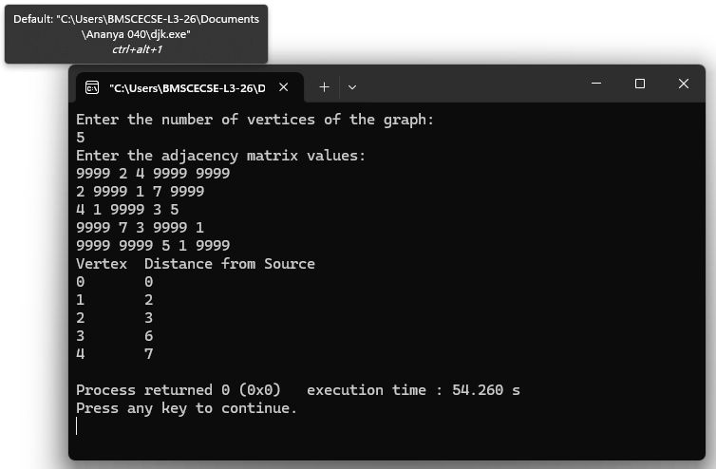

Lab program 11:N-Queens Problem Using Backtracking
#include <stdio.h> #include <stdlib.h> int x[20]; int count = 0; int place(int k, int i) {
int j; for(j = 1; j < k; j++) { if(x[j] == i || abs(x[j] - i) == abs(j - k)) return 0;
} return 1; } void nQueens(int k, int n) {
int i, j; for(i = 1; i <= n; i++) { if(place(k, i)) { x[k] = i; if(k == n) { count++; printf("\nSolution %d:\n", count); for(j = 1; j <= n; j++) { for(i = 1; i <= n; i++) { if(x[j] == i) printf("Q "); else printf(". ");
} printf("\n");
} } else { nQueens(k + 1, n);
}
}
}
} int main() {
int n;
printf("Enter number of queens: "); scanf("%d", &n); nQueens(1, n); if(count == 0) printf("No solution exists"); return 0;
}
OUTPUT:
